Title | Contribution to Grenoble's digital energy twin – Hetrogeneous Data fusion
Abstract | The subject is part of a project contributing to the development of a digital twin for the city of Grenoble, focusing on energy mapping. More specifically, it targets building electricity consumption data. It could serve as a basis for future work on coupling with the electrical and thermal networks (HyMES, FlexRICAN projects, etc.), and ultimately for a multi-energy model.
Objectives | Using a multi-fidelity approach to generate a spatialized electricity consumption model.
Methodology and expected results | To achieve this, we will use a data fusion approach. The available sources are mainly :  - A 2D (Python) data visualization of the city energy system  - LaMetro Geographic Information System (GIS) for topological data on networks (roads, electricity distribution, heating, gas, water, etc.)  - For certain buildings:  - their energy performance diagnosis (DPE)  - actual annual energy consumption  - On the IRISE geographical scale: statistical data on the buildings  - On the scale of a medium-voltage network mesh: electricity consumption at 10-minute intervals.  The aim of this work is to link the topology of Grenoble's electricity network to its urban territory, and thus associate the spatial distribution of buildings with electrical power measured at MV network source substations (HV/MV transformers).  This initial work will make it possible to spatialize and visualize this topology, and to reflect on the link between energy consumption and the urban fabric, such as the potential of buildings for PV production, or the locations for installing electric vehicle charging stations... As the data are not all defined on the same temporal and spatial scale, analyses will be carried out to group or extrapolate them, in order to make comparisons.  For this purpose, a multi-fidelity modeling approach will be used [1], in particular regression models exploiting Gaussian processes.  Various data sources have already been studied: building use homogeneity, building construction period.... [2-6]
References | [1] Meng, X., Babaee, H., & Karniadakis, G. E. (2021). Multi-fidelity Bayesian neural networks: Algorithms and applications. Journal of Computational Physics, 438, 110361.  [2] Hanne Lucido « Grenoble Digital Twins » Rapport technique, stage de PFE, PHELMA Grenoble-INP  [3] Maša Hadži-Nikolić “Data fusion for building energy demand forecasting”, Master Informatique, Université Grenoble Alpes, Specialization Data and Artificial Intelligence  [4] Engy Gabr « Croisement des données de la consommation énergétique (DPE) et la morphologie urbaine de la ville de Grenoble » Rapport de stage M1, laboratoire AAU  [5] Pajot, C.; Artiges, N.; Delinchant, B.; Rouchier, S.; Wurtz, F.; Maréchal, Y. An Approach to Study District Thermal Flexibility Using Generative Modeling from Existing Data. Published in MDPI Books, District Energy System Design: Simulation, Optimization and Decision Support, Inard Christian and Le Dréau Jérôme (Ed.) ISBN 978-3-03936-366-7 https://doi.org/10.3390/books978-3-03936-367-4  [6] Bernardo BLASI VILLARI, Midas CAUBERGS, Manuel MECO GOMEZ, Adrien VALENTIN-ZANINI “Optimizing the energy management of a micro-grid”, rapport de projet collectif ENSE3 2019
Supervision | 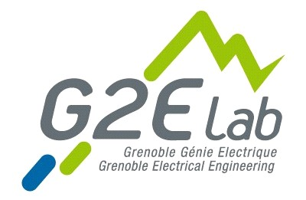  Benoit Delinchant (Prof.), benoit.delinchant@grenoble-inp.fr  Yves Marechal (Prof.) et Kairo (PhD student)

